TEMPLATE FOR THE PREPARATION OF EXTENDED ABSTRACT

First Author
University Department, University Name, Country, email@address1
Second Author
Group, Laboratory Name, Country, email@address2

Keywords: maximum of four separated by commas.

The typing instructions are provided to the authors for the preparation of the extended abstract to be included in the documentation of the International Junior Researcher and Engineer Workshop on Hydraulic Structures.
The Abstract should be prepared as a Microsoft Word Document file which must be submitted by email to the workshop secretariat aprh@aprh.pt . The maximum length for the Abstract is two pages. The Abstract should provide a complete summary of the work carried out. It should contain an introduction stating and justifying clearly the problem and objectives concerning the presentation; a main section where the methodology is briefly delineated; and the main conclusions.
The Abstract must be written in English and may contain text, figures, diagrams, tables, acknowledgements and references. The entire manuscript must be formatted as a single body text, without breaking it into sections. The only differentiated section allowed is the References.

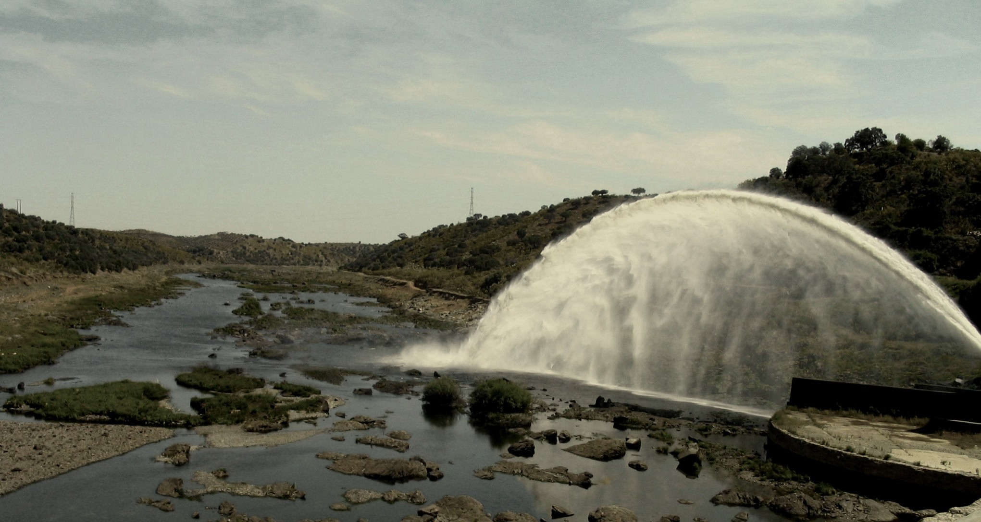
Figure 1 – View of Guadiana river downstream of Alqueva dam.

The text, figures, and tables must be centred and within the limits of the page. The total length of the manuscript, including text, figures, tables, references etc., must not exceed 2 pages. Please do not write anything in the header and the footer. Use Times New Roman 12 pt. typeface fonts for the entire text. All text must be single spaced. No indentation should be made in the first line of a paragraph. Between paragraphs an interval of 6 pt. shall be given. Type the title of the manuscript in bold capitals using Times New Roman 12 pt. typeface. All lines of the title should be centred similar to the title of these instructions. After the last line of the Title, skip two lines and type the name(s) and affiliation(s) of the author(s) centred, as shown. After the affiliation(s) of author(s), skip two lines and write the relevant Keywords. Skip one line and begin the abstract.
Illustrations shall be pasted into the body of the text. Letterings on illustrations must be large enough to be legible. Leave a blank line between the upper boundary of the figure and the text. At the bottom of the figure type the caption of the figure centred as shown. After the caption leave a blank line before continuing with the text. It is the author’s responsibility to obtain a written permission from the original publisher when this applies. Only black and white (with shades of gray) illustrations will be reproduced. The authors should pay attention not to use the colour to distinguish between the different types of lines in a figure. The figures should be referred to as Figure 1.
Use Microsoft Equation Editor or equivalent to write your equations. These should appear left aligned and sequentially numbered starting from 1, such as:
$\text{Fr} = \frac{U}{\sqrt{\text{gh}}}$ (1)
Do not leave blank lines before and after equations. The equation numbers should be written in parenthesis and they must be right aligned. Equations should be referred to as Equation 1. The title of tables shall appear at the top. Leave a blank line between the table title and the adjacent text, as well as between the table and the corresponding caption. The tables should be referred to as Table 1.

Table 1 – Costs of an espresso coffee.

Country | Cost
 | (€)
France | 1.50
Portugal | 0.65
Switzerland | 2.00

In the end of the Abstract, skip on line and include the References section as indicated below. The abstracts revision will take into account their format. If necessary, some minor editing corrections will be done by the conference secretariat. If this effort justifies, the authors may be invited to resubmit a revised version of their abstract.

REFERENCES
Adrian, R.J., Christensen, K.T. & Liu, Z.C. 2000. Analysis and interpretation of instantaneous turbulent velocity fields. Exp. Fluids 29: 275-290.
Schlichting, H. 1968. Boundary-layer theory. New York: McGraw-Hill.
Czernuszenko, W. and Rylov, A. (2004) “3D turbulent flow over irregular bed surfaces”, Proc. River Flow 2004, Naples.

